Standard | Items:
3.OA.03 -  Use multiplication and division within 100 to solve word problems in situations involving equal groups, arrays, and measurement quantities, e.g., by using drawings and equations with a symbol for the unknown number to represent the problem. | 3.0  a. There are 28 wildflowers.  Put them equally into 7 vases.  How many wildflowers will you have in each vase?  Solve and show your work.  ______________________________________________  b. Benjamin is training for his track meet. He runs 3 miles every day for 7 days. How many total miles does he run?  Solve and show your work.  _____________________________________________  c. Write an equation with a symbol for the unknown number. Then solve the problem.  Morgan is making a skirt. She needs 8 pieces of ribbon  that are each 3 inches long. How many inches of ribbon  does she need altogether?  _____________________________________________  d. Write a multiplication equation for the picture.  _______________________________
2.0
a. There are 4 children in Margie's family. They each have 2 goldfish in the family’s fish tank. How many goldfish are there?

___________________________________________

b. Six dogs each buried three bones. How many bones were buried in all?
Write a multiplication equation with a symbol for the unknown.
________________________________________________________

c. How many bones were buried?__________________

d. The array below is a model for the multiplication equation.
6 × 7 = 42

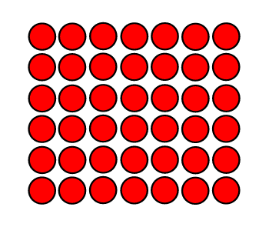

Which division equation is modeled by the same array? Circle your answer.

A. 42 ÷ 6 = 7

B. 42 ÷ 2 = 21

C. 44 ÷ 4 = 11

D. 7 × 6 = 42

3.OA.07 -  Fluently multiply and divide within 100, using strategies such as the relationship between multiplication and division (e.g., knowing that 8 × 5 = 40, one knows 40 ÷ 5 = 8) or properties of operations. By the end of Grade 3, know from memory all products of two one-digit numbers | 3.0  a. $45÷9 =$  Write a related multiplication fact to help you solve this division problem.  __________________________________  b. Which fact sentence does NOT belong in the same fact family as $4 × 5 = 20$?  A $5 × 4 = 20$  B $10 × 2 = 20$  C $20÷4 = 5$  D $20÷5 = 4$
2.0

a. Write one multiplication fact and one division fact represented by this array:

______ x _____= ______

______$÷$_____=______

3.NF.03 -  Explain equivalence of fractions in special cases, and compare fractions by reasoning about their size.  - Understand two fractions as equivalent (equal) if they are the same size, or the same point on a number line. | 3.0  Show $\frac{3}{6}$ and $\frac{1}{2}$ on a number line.
2.0
a. Write an equivalent fraction.
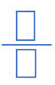

$\frac{2}{4}$=

b. Write an equivalent fraction.

$\frac{2}{3}$=

3.NF.03 -  Explain equivalence of fractions in special cases, and compare fractions by reasoning about their size.  d) Compare two fractions with the same numerator or the same denominator by reasoning about their size. Recognize that comparisons are valid only when the two fractions refer to the same whole. Record the results of comparisons with the symbols >, =, or <, and justify the conclusions, e.g., by using a visual fraction model. | 3.0  a. Use the symbols: >, =, or < to compare these fractions.  $\frac{1}{3}$ $\frac{1}{6}$  Justify your answer with a model.  b. John drew the picture below. He says it proves that the shaded fractions are the same size. Is he correct? Why or why not?  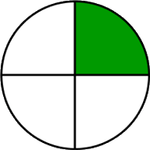
2.0

Use the models to compare. Use >, <, or =.

$\frac{2}{4}$ $\frac{2}{6}$

3.MD.07b  Multiply side lengths to find areas of rectangles with whole-number lengths.  Multiply side lengths to find areas of rectangles with whole-number side lengths in the context of solving real world and mathematical problems and represent whole-number products as rectangular areas in mathematical reasoning. | 3.0 (a) John has a garden in his backyard. One side measures 7 meters and the other side is 2 meters. Using multiplication, find the area of his garden.  3.0 (b)Draw and label a rectangle that has an area of 12 square units.
2.0 (a). Lisa’s bedroom rug is 2 feet long and 6 feet wide. What is the area of her rug?

(b). Find the area of this rectangle.

6
4

(c.) The area of this rectangle is 15 square cm. The shorter side measures 3 centimeters. What is the length of the longer side?
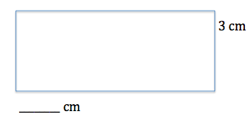
3.G.01 -  Understand that shapes in different categories (e.g., rhombuses, rectangles, and others) may share attributes (e.g., having four sides), and that the shared attributes can define a larger category (e.g., quadrilaterals). Recognize rhombuses, rectangles, and squares as examples of quadrilaterals, and draw examples of quadrilaterals that do not belong to any of these subcategories. | 3.0  Look at the shapes below.  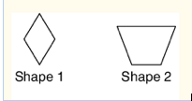  List two attributes that both shapes have in common.
2.0

Circle all the words that describe this shape:

Square Rhombus Quadrilateral

Trapezoid Rectangle Parallelogram

2.0 Circle the figure which is NOT a square, rectangle, rhombus, or parallelogram:

